Littleneckhalfshell
- Plunderer
- Member

- 390 posts
- Gender:Male
- Location:Hudson Valley, NY
- Interests:Blacksmithing, hunting, fishing, stuff.......
(IP: 68.193.4.238) ·
Posted January 1, 2008 · Report post
I know that this is a wide topic, but thinking about bottles, and that many of the types of bottles that exist today were not available in the GAOP (such as case bottles) and that Onion bottles ARE period correct, I started thinking about other containers. What would look correct in a camp, on a wharf, or aboard ship? I know that both wet and dry casks were used but that some things may make even a barrel 'non-period' such as galvanized steel hoops. What would be other forms of containers be, and in their proper material and form?
I assume that some kind of cloth sack or bale wrapping was used in the period. What size, shape and material? Is Burlap ok, or would it have to be canvas sail cloth? non-cotten? etc.
Crockery of course existed, but what shape would crocks or jugs have taken to be period correct? as well as would they be glazed, or unglazed, and if glazed, what color? or would 'salt' glazing be period?
Wooden boxes or crates are a whole subject in themselves. A simple box can be made out of six boards nailed together, would that be period correct? sometimes you see boxes with reinforcing battens on the edges and with diagonal cross braces. Dovetails, big or small? What would a common period box look like? Also, what would common dimensions be?
Baskets? shape, size and material?

- Quote
- Edit

blackjohn
- Iron Age Hero Lost at Sea
- 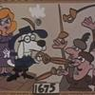
- Member

- 3,745 posts
- Gender:Male
- Location:Columbia, Md
- Interests:Stuff... and junk.
(IP: 205.156.36.11) · ·
Posted January 2, 2008 · Report post
I seem to recall we had a similar thread once... or maybe it was about seachests... I dunno... but either way, this Backhuysen probably gives you a good idea of the bags, chests, etc.
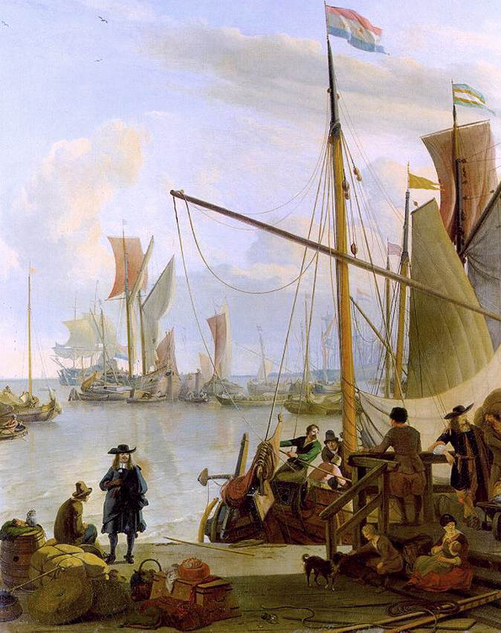

- Quote
- Edit
- Options

Littleneckhalfshell
- Plunderer
- Member

- 390 posts
- Gender:Male
- Location:Hudson Valley, NY
- Interests:Blacksmithing, hunting, fishing, stuff.......
(IP: 68.193.4.238) · ·
Posted January 2, 2008 · Report post
yes, sea chests have been discussed, but they are a specialized box, no? or are they typical of any ship board storage box? or were there not any 'boxes' ? were only barrels used? say for example I had some china to ship, would I put it into a 'box' or a barrel? Are square or rectangular boxes non period? and do they arrive on the scene at a later time?
In the picture there is a bale wrapped in rope and a barrel, also what seems to be baskets, and a sea chest, but No boxes, as I usually think of boxes. Are there any period pictures with boxes?
Found a site that has line drawings of the evolution of wine bottles, which I will post under a new thread, but it would be good to have similar research on other Containers as an archive for those who wish to refine their historical presentation.

- Quote
- Edit
- Options

blackjohn
- Iron Age Hero Lost at Sea
- Member

- 3,745 posts
- Gender:Male
- Location:Columbia, Md
- Interests:Stuff... and junk.
(IP: 205.156.36.11) · ·
Posted January 2, 2008 · Report post
I know boxes were used for transport. One interesting archaeological find was a shipping crate full of cacao beans... and pistols. The question became one of where the pistols being smuggles in with the cacao beans, or where they being transported with them as a sort of packing peanut. Most seem to favor the packing peanut hypothesis, pointing to the fact that containers often were packed in such a manner.
Also, either in this forum of the Pirate Brethren forum or both, I'm sure I've brought up the crate full of muskets found on La Belle. Actually, the book on La Belle has a pretty good map showing locations of boxes and barrels, with a general guide to what was contained in each. It has been a while since I looked at it, but I do remember it standing out in my mind as a pretty cool example of what was found on a transport, even a specialized transport such as La Belle.

- Quote
- Edit
- Options

blackjohn
- Iron Age Hero Lost at Sea
- Member

- 3,745 posts
- Gender:Male
- Location:Columbia, Md
- Interests:Stuff... and junk.
(IP: 205.156.36.11) · ·
Posted January 2, 2008 · Report post
Here's a link to the part of the report re: cacao beans &c.
Linky

- Quote
- Edit
- Options

Red Maria
- Dread Pyrate
- Member

- 1,057 posts
(IP: 216.31.151.2) · ·
Posted January 2, 2008 · Report post
RHJ
You might want to peruse the following sites:
http://www.smoke-fire.com/
http://www.gggodwin.com/page7.htm
http://www.thequartermastergeneral.com/
http://www.jas-townsend.com/
Sorry I didn't link to a specific page but there was too many places to point to. A search engine search by 18th century sutler will get you more sites with more examples.

- Quote
- Edit
- Options

Red Maria
- Dread Pyrate
- Member

- 1,057 posts
(IP: 216.31.151.2) · ·
Posted January 2, 2008 · Report post
Here's another one
http://www.raystownforge.com/
They even sell period crates!

- Quote
- Edit
- Options

CrazyCholeBlack
- Scourge o' the 7 Seas
- Member

- 1,578 posts
- Gender:Female
- Location:Illinois
- Interests:Everything! Historic clothing, sewing, fabric dying, cooking, mead, ale, astronomy, celestial navigation, reading, music, film making, blogging & pillaging the internet for visual inspirations.
(IP: 24.159.244.10) · ·
Posted January 2, 2008 · Report post
Quote
Crockery of course existed, but what shape would crocks or jugs have taken to be period correct? as well as would they be glazed, or unglazed, and if glazed, what color? or would 'salt' glazing be period?
I always turn to J. Henderson for my pottery. Jay does beautiful work, glazed, stoneware and custom. All of mine is from them now (& not just because they take coffee in trade )
http://artifacts.brigandsfolie.com/

- Quote
- Edit
- Options

Littleneckhalfshell
- Plunderer
- Member

- 390 posts
- Gender:Male
- Location:Hudson Valley, NY
- Interests:Blacksmithing, hunting, fishing, stuff.......
(IP: 68.193.4.238) · ·
Posted January 3, 2008 · Report post
Red Maria said ""Sorry I didn't link to a specific page but there was too many places to point to. A search engine search by 18th century sutler will get you more sites with more examples.""
See, there is the problem, ""18th century sutler's"" most of them are dealing with stuff from the 1740's onward. Jas. Townsend particularly speaks of them being 1750-1840 or something like that.
My difficulty is finding on the sites information about the correct time period of the items, all the sites are quite general in their description of the time period. The Golden Age of Piracy is the common designation given the period roughly spanning from the 1680s to the 1720s, so a box from 1740 is out of place and time. But what would a box from the year 1680 look like? It may well look the same as a box from 1780, but I have found no testimony yet if that is true or not. Bottles changed over time, so did pottery, Just trying to get a handle on the various things that might make up a proper depiction of the time period.

- Quote
- Edit
- Options

blackjohn
- Iron Age Hero Lost at Sea
- Member

- 3,745 posts
- Gender:Male
- Location:Columbia, Md
- Interests:Stuff... and junk.
(IP: 205.156.36.11) · ·
Posted January 3, 2008 · Report post
Which is why I like Ivor Noel Hume's book... he has some good diagrams showing how the shapes of things changed over time.

- Quote
- Edit
- Options

CrazyCholeBlack
- Scourge o' the 7 Seas
- Member

- 1,578 posts
- Gender:Female
- Location:Illinois
- Interests:Everything! Historic clothing, sewing, fabric dying, cooking, mead, ale, astronomy, celestial navigation, reading, music, film making, blogging & pillaging the internet for visual inspirations.
(IP: 24.159.244.10) · ·
Posted January 3, 2008 (edited) · Report post
Julia Smith has a good basic article about pottery during the generic "colonial" era. It does a good job differentiating between different types of pottery/glaze techniques and some rough dates for colonial production. Oh, don't forget to check the bottom for suggested further reading (tip #1 for how to find all the good history books )
http://www.juliasmith.com/historicpottery/articles.htm
The virtual site for the Phips Homestead has some photos of shards. Everything from delft to plain red ware is shown. The sites end date is still slightly pre GAoP (1676) but with something as hard to find as proper pottery using a wider year range can be helpful in finding basic information.
http://w3.salemstate.edu/~ebaker/Phipsweb/...phipsalbum.html
Edited January 3, 2008 by CrazyCholeBlack

- Quote
- Edit
- Options

blackjohn
- Iron Age Hero Lost at Sea
- Member

- 3,745 posts
- Gender:Male
- Location:Columbia, Md
- Interests:Stuff... and junk.
(IP: 71.166.45.129) · ·
Posted January 4, 2008 · Report post
A quick run down of casks and crates found on La Belle.
88 barrels, mostly white oak staves, some beech and some willow
split willow and chestnut was used for the withies on all but the largest casks
10 wooded boxes, probably pine
- 2 contained trade goods
1 carpentry tools & other items
4 muskets and swords
1 undetermined
1 found outside hull, based on style probably held personal items
1 kettles, pewter plates, candlestick holders, a ladle
The crate holding trade beads was constructed of sawn white pine boards, 28" long, 11 inches wide and 11 inches deep.
Also worth noting, 74 brass tacks were found. They were found aft, and could possibly have decorated a leather covered chest that rotted away over time.

- Quote
- Edit
- Options

Gentleman of Fortune
- Dread Pyrate
- Member

- 1,456 posts
- Gender:Male
- Location:Germany... Franconia (northern Bavaria)
- Interests:I *used* to be an environmental scientist, until I married a DoDDs teacher in 1997. Since then, I have been living in, and traveling around, Europe (First the UK, now Germany).
My hobbies are all the "usual suspects" for those interested in re-enacting and Golden Age of Piracy stuff.... but I have drifted away from the pirate scene as my location and young family don't allow for any more than "virtual" pirate participation. Besides Piracy, I am into Reverend Guitars and Vintage Corvettes.
(IP: 217.229.241.252) · ·
Posted January 5, 2008 · Report post
Cool Stuff John!
Thanks for posting it.
GoF

- Quote
- Edit
- Options

blackjohn
- Iron Age Hero Lost at Sea
- Member

- 3,745 posts
- Gender:Male
- Location:Columbia, Md
- Interests:Stuff... and junk.
(IP: 71.166.45.129) · ·
Posted January 5, 2008 · Report post
Sure thing Greg, my pleasure.
Some more.
Ceramic containers
31 complete or mostly complete vessels found mostly in the cargo holds. Most were coarse earthenware not highly fired, of a type produced in Saintonge, 70 miles inland from La Rochelle. Twelve were stoneware. Others were faience.
Glass bottles
Fifteen were found. Most were case bottles, though onion bottles were also found. The part I find most interesting is that several pewter screw tops were found, some still attached to the tops of bottles. The threaded caps could be tightened just like a modern screw cap.
Archaeology... it's so cool!

- Quote
- Edit
- Options

Littleneckhalfshell
- Plunderer
- Member

- 390 posts
- Gender:Male
- Location:Hudson Valley, NY
- Interests:Blacksmithing, hunting, fishing, stuff.......
(IP: 68.193.4.238) · ·
Posted January 5, 2008 · Report post
Ok, La Belle, sank in 1686, so it is a snapshot of what might be aboard any vessel of that time, and the time is in the GAOP. You mention 'Case bottles' which seemed to be in higher numbers than Onion bottles. On page 69 of "A guide to Artifacts of Colonial America" they show a stright sided 'case bottle' but in other books, I have seen tapered sided case bottles. For some reason, I have always thought of case bottles as being just after GAOP but apprently they are not, and yet, it would seem that others besides myself are under the impression that Onion bottles are older, because they are formed with basically a blow pipe and do not require a mold. Molded bottles are throught of being 'post' period.
Are case bottles not molded bottles? Are they formed with paddles after being blown? Everyone seems to be after an onion bottle, but I would think that modern square bottles might be easier to come by, I can think of a few gin bottles that might be altered a little. But back to why I initially began this thread...... It would be nice if there was a sort of 'Manual' depicting with color-size-shape information on the various containers, along the line of how people have discussed and shared information on clothing patterns and proper materials as well as stitching, and the discussions on proper side arms, etc. In the area of drink containers, we know that Casks, ceramic bottles (Bellarmine or Bartmann Bottles - again from 'a guide to artifacts...') were in period and Case bottles (dark glass) and even with pewter screw tops! no less. So maybe a Gibley's Gin is not too far off of period if I colored the glass a dark green But seriously, trying to sort through all the stuff and trying to be more historical than Hollywood is not very easy. There is a lot out there for the 1740 ff. as to what is historically correct, but precious little for the GAOP.

- Quote
- Edit
- Options

Captain Pogue
- Ship's Master
- Member

- 190 posts
- Location:Portland, Or
- Interests:All things Piratical.<br>Escaping Texas and moving up to the Northwest.<br>Making things.
(IP: 66.68.185.229) · ·
Posted January 6, 2008 · Report post
Here is a case (gin) bottle right after the GAoP, according to the current owner. It was blown not molded...
Ebay gin bottle
Towards the bottom of the page is a guy selling a bunch of "rare" gin bottles. They look kind of cool...
Ebay Gin bottle auctions
Don't know if this is helpful at all, probably not... nevermind
Actually I came across some references to some antique bottle clubs, they might have some answers. I'd say something about how weird of a hobby collecting antique bottles is... but for some reason I feel I should refrain...
Mr. Kettle signing off

- Quote
- Edit
- Options

Littleneckhalfshell
- Plunderer
- Member

- 390 posts
- Gender:Male
- Location:Hudson Valley, NY
- Interests:Blacksmithing, hunting, fishing, stuff.......
(IP: 68.193.4.238) · ·
Posted January 6, 2008 · Report post
"Here is a case (gin) bottle right after the GAoP, according to the current owner. It was blown not molded..."
1770-1800 is quite a bit after GAOP in my estimation. And then there is the question as to how do you blow a square bottle? In a sense, even molded bottles are blown, they are just blown inside a mold.
But were early case bottles blown round and then flattened on four sides by hand blocking?

- Quote
- Edit
- Options

Captain Pogue
- Ship's Master
- Member

- 190 posts
- Location:Portland, Or
- Interests:All things Piratical.<br>Escaping Texas and moving up to the Northwest.<br>Making things.
(IP: 66.68.185.229) · ·
Posted January 6, 2008 · Report post
There is always this, if it's not in here it might point you in the right direction...
Historic Glass Bottle Identification & Information Website

- Quote
- Edit
- Options

blackjohn
- Iron Age Hero Lost at Sea
- Member

- 3,745 posts
- Gender:Male
- Location:Columbia, Md
- Interests:Stuff... and junk.
(IP: 71.166.45.129) · ·
Posted January 6, 2008 · Report post
From what I recall, you blow a glass case bottle by blowing it into a pre-formed mold.

- Quote
- Edit
- Options

William Brand
- Mercury Malefactor
- Admin

- 8,884 posts
- Gender:Male
- Location:Logan, Utah
- Interests:My name is William Pace and I live and work as a graphic designer, illustrator and photographer in Northern Utah. I'm married to the lovely Tracy Pace and we have three children. In addition to all things art, I enjoy traveling and meeting new people from every walk of life. I've always been a fan of history, theology, and of course, Pyracy.
http://www.youtube.com/watch?v=PSkt-q-HihQ
(IP: 166.70.59.121) · ·
Posted January 6, 2008 · Report post
There are some interesting containers found here...
http://www.bunrattycollection.com/search.php?r=16

- Quote
- Edit
- Options

Captain Midnight
- Pyrate Captain
- Member

- 643 posts
- Gender:Male
- Location:Richland, GA USA
- Interests:I am the Captain of The Cursed Few, the deadliest pirate crew on the East Coast. I am a charter member of the Order of Leviathan, or "Devil's Dozen".
(IP: 74.244.192.183) · ·
Posted January 6, 2008 (edited) · Report post
William Red Wake said:
There are some interesting containers found here...
http://www.bunrattycollection.com/search.php?r=16
Oh man! That is an absolutely awesome site! Thanks so much for that link, William! I have been making leather tankards (or "blackjacks") for a number of years, but I really like the leather costrels shown on this site. I am going to try to make one of them! It would be a very authentic canteen, I think...
Edited January 6, 2008 by Captain Midnight

- Quote
- Edit
- Options

Gentleman of Fortune
- Dread Pyrate
- Member

- 1,456 posts
- Gender:Male
- Location:Germany... Franconia (northern Bavaria)
- Interests:I *used* to be an environmental scientist, until I married a DoDDs teacher in 1997. Since then, I have been living in, and traveling around, Europe (First the UK, now Germany).
My hobbies are all the "usual suspects" for those interested in re-enacting and Golden Age of Piracy stuff.... but I have drifted away from the pirate scene as my location and young family don't allow for any more than "virtual" pirate participation. Besides Piracy, I am into Reverend Guitars and Vintage Corvettes.
(IP: 217.229.206.145) · ·
Posted January 7, 2008 · Report post
That is a GREAT site!
My only caution is that some things are just marked "18 Century", which of course, covers 100 years and only the first 30 or so relevant to GAoP. The Late 17th Century stuff is way cool too!
GoF

- Quote
- Edit
- Options

William Brand
- Mercury Malefactor
- Admin

- 8,884 posts
- Gender:Male
- Location:Logan, Utah
- Interests:My name is William Pace and I live and work as a graphic designer, illustrator and photographer in Northern Utah. I'm married to the lovely Tracy Pace and we have three children. In addition to all things art, I enjoy traveling and meeting new people from every walk of life. I've always been a fan of history, theology, and of course, Pyracy.
http://www.youtube.com/watch?v=PSkt-q-HihQ
(IP: 166.70.59.121) · ·
Posted January 7, 2008 (edited) · Report post
Agreed. Always read about each item carefully.
Here is a site specifically devoted to the history of drug containers and labels. It has some fascinating items from the period and earlier.
http://books.google.com/books?id=N4N9bsxc2...XCcpg17SRfZQGN4
And here is another site. This one is maintained by the Pewter Society and it contains a great glossary of pewter terms.
http://home1.gte.net/vzn05wao/pcca/glossary.htm
Edited January 7, 2008 by William Red Wake

- Quote
- Edit
- Options

Captain Midnight
- Pyrate Captain
- Member

- 643 posts
- Gender:Male
- Location:Richland, GA USA
- Interests:I am the Captain of The Cursed Few, the deadliest pirate crew on the East Coast. I am a charter member of the Order of Leviathan, or "Devil's Dozen".
(IP: 166.102.243.129) · ·
Posted January 7, 2008 · Report post
What about the costrels and other leather containers? It has always been my understanding that such ware was used well into our period and beyond? Somewhere I once read that they were still using leather blackjacks to drink from in English taverns in the 1800's...

- Quote
- Edit
- Options

Gentleman of Fortune
- Dread Pyrate
- Member

- 1,456 posts
- Gender:Male
- Location:Germany... Franconia (northern Bavaria)
- Interests:I *used* to be an environmental scientist, until I married a DoDDs teacher in 1997. Since then, I have been living in, and traveling around, Europe (First the UK, now Germany).
My hobbies are all the "usual suspects" for those interested in re-enacting and Golden Age of Piracy stuff.... but I have drifted away from the pirate scene as my location and young family don't allow for any more than "virtual" pirate participation. Besides Piracy, I am into Reverend Guitars and Vintage Corvettes.
(IP: 217.229.196.76) · ·
Posted January 7, 2008 (edited) · Report post
As promised.... more containers.
Here are some croppings from a GAOP era Painter named Abraham Storch (or Storck)
They are from the late 1690s and show "Containers" either by, going on, or coming off, ships.
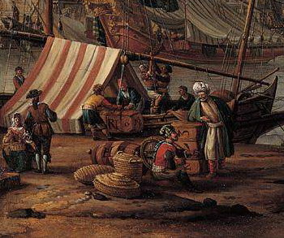
This one shows what appears to be wooden trunks (Check out the big lettering), baskets, and barrels.
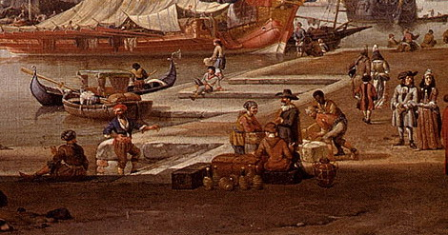
A Storck again, a 1696 Venetian Scene (cropped by me) that shows what appears to be woven/basket jug containers with either glass or ceramic jugs, wooden boxes, and canvas covered goods.
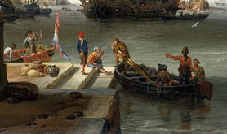
Last of my A Storch croppings. This one is 1697 dated and has wooden hooped "barrel", and fabric sacks. Also in the painting (but not this cropping) is a guy carrying a box and some folks sitting on fabric wrapped goods.
Here is an interesting engraving from about 1700 from a German artist Weigel. He made a series of "Occupation" engravings from that time... I guess the German Version of "Cries of London".
This is the "Sailor"
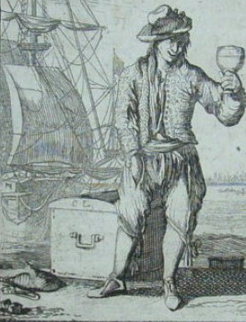
Interesting domed sea chest....
This last one is from an Early Johnson edition and is one of the Black Beard engravings. I cropped the pic for info that relates to this thread.
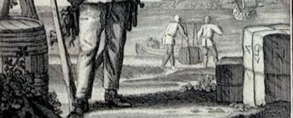
Again, fabric wrapped goods with writing on them, and a barrel with wooden hoops.
more on the hoops to follow.....
Edited January 7, 2008 by Gentleman of Fortune

Gentleman of Fortune
- Dread Pyrate
- Member

- 1,456 posts
- Gender:Male
- Location:Germany... Franconia (northern Bavaria)
- Interests:I *used* to be an environmental scientist, until I married a DoDDs teacher in 1997. Since then, I have been living in, and traveling around, Europe (First the UK, now Germany).
My hobbies are all the "usual suspects" for those interested in re-enacting and Golden Age of Piracy stuff.... but I have drifted away from the pirate scene as my location and young family don't allow for any more than "virtual" pirate participation. Besides Piracy, I am into Reverend Guitars and Vintage Corvettes.
(IP: 217.229.196.76) · ·
Posted January 7, 2008 · Report post
Barrels, Tons, Pins, Hogsheads etc.
There is a reference to a document that says for Royal Navy Ships going on a LONG sea voyage, that a portion of the containers for Beer could be in Metal Hooped barrels.
(This information was provided by Cpt Tightpants... if you search for barrels at the pub, you should find it).
Anyway,
All of the pictures of barrels, from the smallest to hogs headish ones that I have found depicted in paintings or engravings seem to have wooden hoops. I will let you draw your own conclusions, and I really don't want to get into the same argument again but I thought I would post some pictures for the new folks (and old folks that haven't tired of this yet).
First
The previous post has an Early Edition of Johnson and shows Black Beard with a wooden hooped barrel.
Second
Weigel's "Cooper" circa 1700
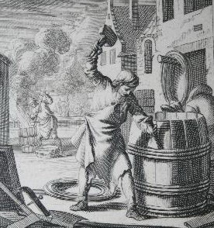
Third
This is from Van Mieris' 1718 "Peepshow". I cropped it to the important bits, but there are three barrels, all with wooden hoops.
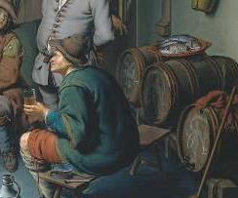
GoF

- Quote
- Edit
- Options

William Brand
- Mercury Malefactor
- Admin

- 8,884 posts
- Gender:Male
- Location:Logan, Utah
- Interests:My name is William Pace and I live and work as a graphic designer, illustrator and photographer in Northern Utah. I'm married to the lovely Tracy Pace and we have three children. In addition to all things art, I enjoy traveling and meeting new people from every walk of life. I've always been a fan of history, theology, and of course, Pyracy.
http://www.youtube.com/watch?v=PSkt-q-HihQ
(IP: 166.70.59.121) · ·
Posted January 7, 2008 · Report post
Gentleman of Fortune said:
This one shows what appears to be wooden trunks (Check out the big lettering), baskets, and barrels.
The objects marked with letters look like large, wrapped bales of textiles or soft goods. Very nice pictures.

- Quote
- Edit
- Options

Captain Midnight
- Pyrate Captain
- Member

- 643 posts
- Gender:Male
- Location:Richland, GA USA
- Interests:I am the Captain of The Cursed Few, the deadliest pirate crew on the East Coast. I am a charter member of the Order of Leviathan, or "Devil's Dozen".
(IP: 74.244.192.183) · ·
Posted January 7, 2008 · Report post
Just perusing on-line and found this link detailing a bit of history for leather drinking vessels and other containers.
Leather Drinking Vessels
Here is a replica of a leather tavern mug or "blackjack" from 1700, right in our period, with the mark of the crown which signified that it held a full pint. Also, here is a pic of the official decree poster which required the vessels to be so marked.
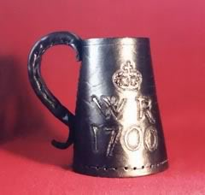
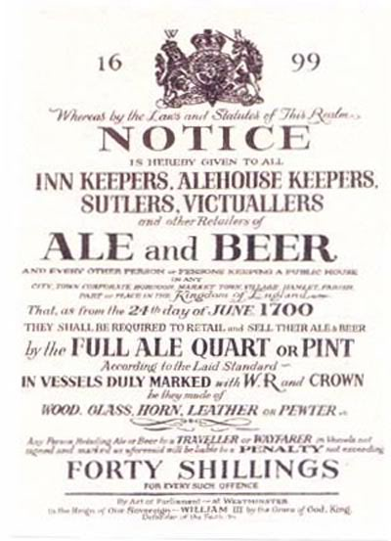

- Quote
- Edit
- Options

Black Hearted Pearl
- Scourge of Everything
- 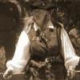
- Moderator

- 2,055 posts
- Gender:Female
- Location:winds of the seas
- Interests:I'm sailing away in the morning.
(IP: 130.13.38.89) · ·
Posted January 10, 2008 (edited) · Report post
blackjohn said:
A quick run down of casks and crates found on La Belle.
88 barrels, mostly white oak staves, some beech and some willow
split willow and chestnut was used for the withies on all but the largest casks
10 wooded boxes, probably pine
- 2 contained trade goods
1 carpentry tools & other items
4 muskets and swords
1 undetermined
1 found outside hull, based on style probably held personal items
1 kettles, pewter plates, candlestick holders, a ladle
The crate holding trade beads was constructed of sawn white pine boards, 28" long, 11 inches wide and 11 inches deep.
Also worth noting, 74 brass tacks were found. They were found aft, and could possibly have decorated a leather covered chest that rotted away over time.
You forgot the 4 - 4lb cannons on board, since you listed the muskets and swords. I've saw the artifacts from the La Belle up close just this past Thanksgiving. The La Belle was found off the coast of my hometown, Bay City Texas in Matagorda Bay and the local Museum had several on exhibit. It was difficult to take pictures as it was all behind glass, but I did manage to get some great pictures of the cannon.

Here's a picture of some wooden apostles for holding gun powder.

Edited January 10, 2008 by Black Hearted Pearl

- Quote
- Edit
- Options

Black Hearted Pearl
- Scourge of Everything
- Moderator

- 2,055 posts
- Gender:Female
- Location:winds of the seas
- Interests:I'm sailing away in the morning.
(IP: 130.13.38.89) · ·
Posted January 10, 2008 · Report post
Here's a picture of bundle I took at the American Heritage Festival. He made it from painters cloth that he painted and then wrapped with rope.

I understand it made a great seat.

- Quote
- Edit
- Options

Silkie McDonough
- Proprietress of the Sealkies Hide
- Moderator

- 5,695 posts
- Gender:Female
- Location:I have been a Virginian for 2 months now. LOVING it.
- Interests:Music, vocalizing, Irish balads. I love to draw, I do pencile portraits/detail drawings for barter and sale. The link in in my signature. Ireland, its history and culture. Sewing garb, mostly for myself. The arm of a strong gentleman round my waist.
Unfortunately, I don't do nearly enough of any of a these.
(IP: 68.80.124.20) · ·
Posted January 10, 2008 · Report post
Black Hearted Pearl said:
Here's a picture of bundle I took at the American Heritage Festival. He made it from painters cloth that he painted and then wrapped with rope.
*image removed*
I understand it made a great seat.
I can also see the value when traveling to events. bring in the fabric and rope wrap something local. If it is just for show wrap old cardboard or NPC wooden boxes then burn them on the final night!

- Quote
- Edit
- Options

Captain Jim
- Captain Jim for Captain!
- Member

- 2,254 posts
- Gender:Male
- Location:Off the coast of Tampa Bay (Unfortunately, inland from the coast)
- Interests:I'm 57, formerly a wildlife ecologist and biologist, now a stay-at-home dad. I grew up on the west coast of Florida, where Anna Maria Sound and Tampa Bay were my playground. My interests include, but are not limited to cannon, black powder arms, history, fishing the flats, sailing, fine wood working, flint gun building, hunting, good gun dogs. Above all, my wife and children.
(IP: 12.195.96.35) · ·
Posted January 10, 2008 · Report post
Quick aside...I worked in the restaurant biz for years and once knew a waiter guy who migrated: North in the summer and South in the winter. Each time he arrived and found a new apartment he would fashion furniture out of cardboard: glue up stacks of flattened boxes and then carve out couches, tables, chairs and beds. These he would cover with salvaged foam and cheap cloth glued and stapled in place. You couldn't tell what they were made of. At the end of each season he had one hell of a bonfire.
I now return you to yor regularly scheduled informational thread.

